**PA 307.6.1 - Practice Assignment   
Creating a Wireframe for Admin and User pages**

**Assignment Objective**

In this assignment , by using the Bootstrap, you will design a admin page and User page

**Introduction to Wireframe for your admin page and user data**

A wireframe is a two-dimensional illustration of a page’s interface that specifically focuses on space allocation and prioritization of content, functionalities available, and intended behaviors. For these reasons, wireframes typically do not include any styling, color, or graphics. Wireframes also help establish relationships between a website’s various templates.

**Requirements**

Look at different websites for inspiration if necessary. You will create an admin page and user page.

When designing an admin page, your goal is not to create a complex design. Your goal is to quickly and easily interact with the data and content.

The easier, more intuitive, and understandable the interface is, the faster you can perform tasks and analyze the data presented on the dashboard.

Your user page should have at least one table to show data for your capstone project. Users should be able to edit their personal information.

Easy to use drawing software available

* Google Drawing
* Paint (Windows)
* Click here [Bootstrap examples](https://getbootstrap.com/docs/5.2/examples/)

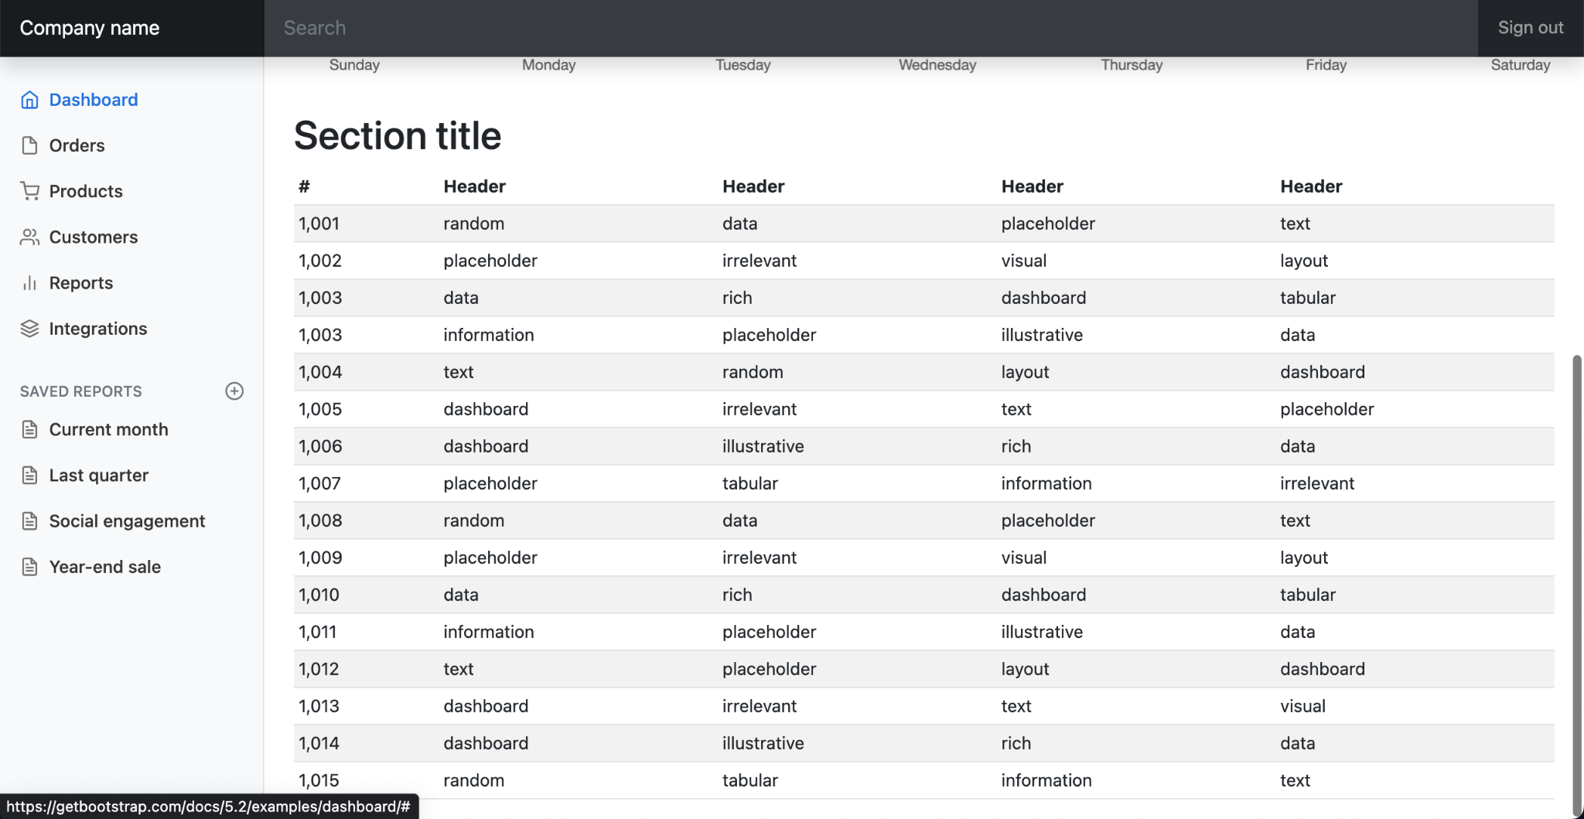

**Submission Instructions:**

Include the following deliverables in your submission -

* + Submit your source code or screenshots using the Start Assignment button in the top right corner of the assignment page in Canvas.

| **Instructions for Canvas Assignment Creation** |
| --- |
| **Assignment Name: PA 307.6.1 - Practice Assignment Wireframe Admin and User**  **Points: 100**  **Assignment Group: Module 307 - Fundamentals of HTML/CSS (Not graded)**  **Display Grade As: Complete/Incomplete**  **Do not count this assignment towards the final grade: Checked**  **Submission Types: File Upload Everything else is the default.** |